DnH_ Figurehead_Contacts_v1

1. Clare Balding

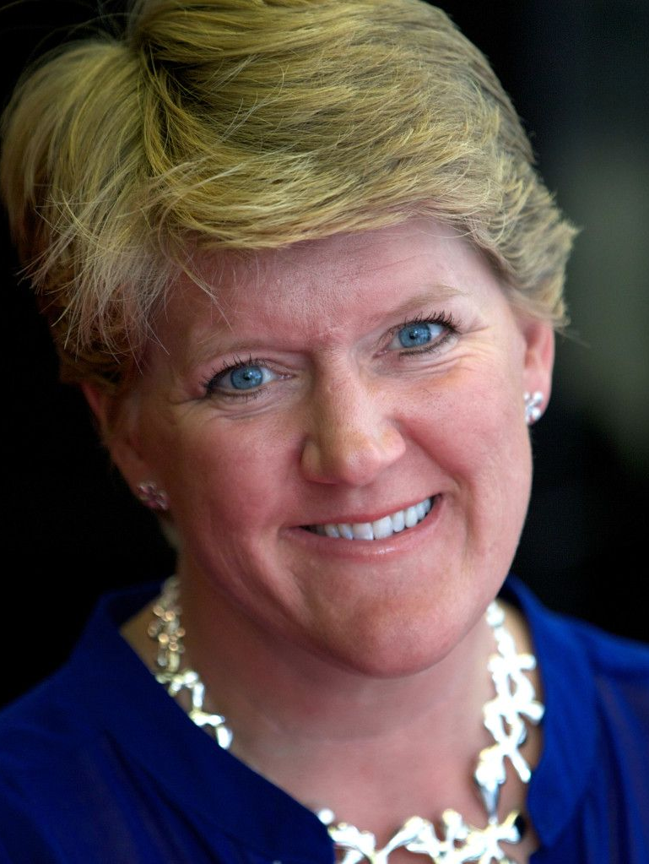
Bio:
Clare is a renowned broadcaster, author, and advocate for equality and kindness. Her voice is trusted across the UK, and her affinity for dogs is well documented in her media work and personal life.

Animal Welfare:
Clare is a long-time supporter of Greyhound Trust and animal adoption. She regularly promotes rescue over purchase on major platforms.

Contact:
Via Knight Ayton Management – info@knightayton.co.uk

2. Peter Egan

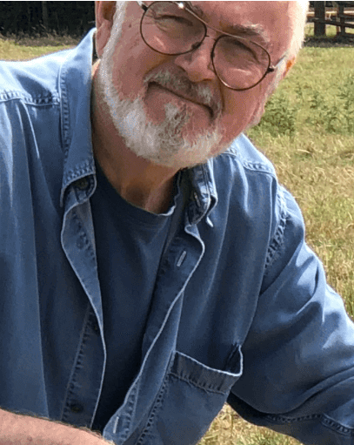
Bio:
Peter is a celebrated British actor and lifelong vegan, respected for his unwavering commitment to animal welfare. He is known for combining gravitas and compassion.

Animal Welfare:
Peter serves as ambassador for Animals Asia and RSPCA, vocally supports ethical rescue, anti-cruelty campaigns.

Contact:
Public contact via Twitter (@PeterEgan6) or through Animals Asia foundation.

3. Deborah Meaden

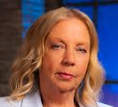
Bio:
Business icon, Dragons' Den, champions ethical causes, credible, compassionate.

Animal Welfare:
Strong supporter of Dogs Trust and campaigns against puppy farms, unethical breeding.

Contact:
Via James Grant Group – contact@ygm.com

4. Ricky Gervais

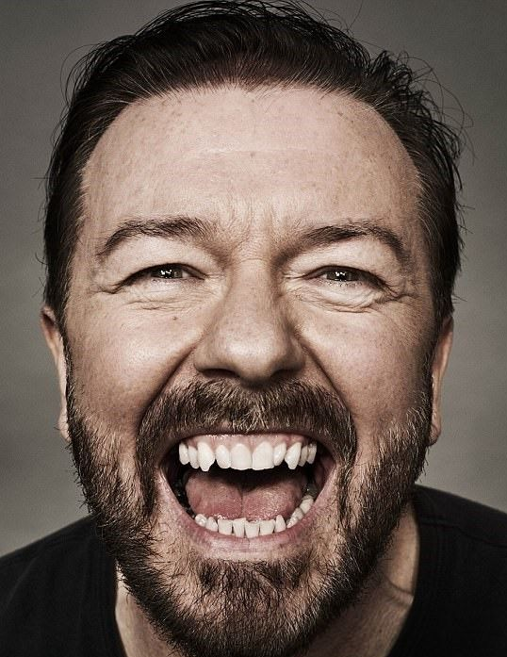
Bio:
Comedian, actor, known globally, most visible celebrity supporter of animal rights/rescue.

Animal Welfare:
Supports PETA Humane Society International. Actively promotes adoption, condemns cruelty.

Contact:
Publicist Jo Milloy – jo@jomilloy.com

5. Marc Abraham (Marc the Vet)

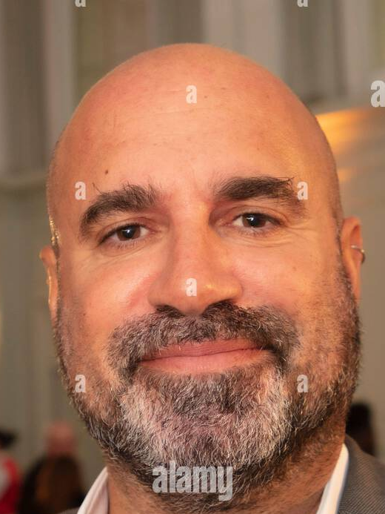
Bio:
Celebrity veterinarian and activist behind Lucy’s Law, Marc is one of the UK’s most trusted voices in animal rescue and protection.

Animal Welfare:
Founder of PupAid, and advocate behind Lucy’s Law which banned puppy farming in the UK.

Contact:
Direct via website: https://www.marcthevet.com/contact/

